*Florida International University*

*School of Computing and Information Sciences*

Software Engineering Focus

Feature Document

User Story ID #331

**Name:** Keep track of visited location

**Team Member(s): Juan Hernandez**

**Project: Virtual Roll Call 4.0**

**Product Owner(s)**: Jason Cohen

**Mentor(s)**: Juan Caraballo

**Instructor**: Masoud Sadjadi

**User Story Name:** Keep track of visited location

* Description: As an officer, I would like to track the locations I visited so it can help me identify the locations I haven’t been at.

Acceptance Criteria

* Provide the ability to the officer to mark and unmarked locations in the View Watch Order screen grid.
* Provide a button to unmark all.
* Save changes so that when officer logs out and logs back in, his/her locations are marked as them left them.

**Use Case**

* Name: Track Visit Loc
* Actor: Juan Hernandez
* Preconditions: Juan is logged in. Juan have watch orders in the the View Watch Order Screen.
* Description <Flow of events>: Juan can click the row of the location that was visited to mark it. Juan can click the marked row to unmark it. Juan can click the “Unselect All Locations” button to unmarked all the locations.

**Use Case Diagram**

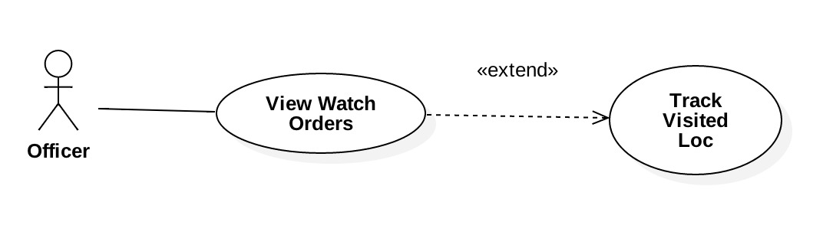

**Sequence Diagram**

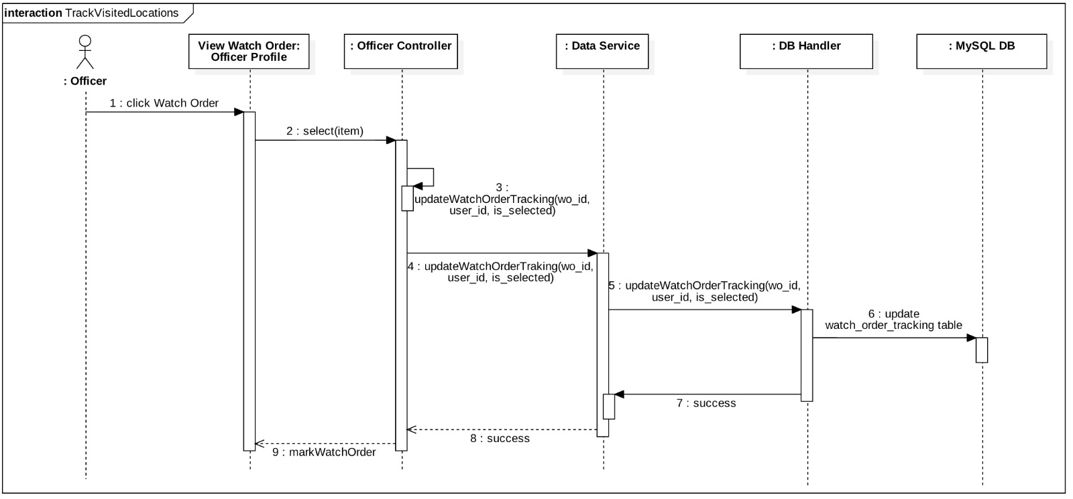

**Class Diagram**

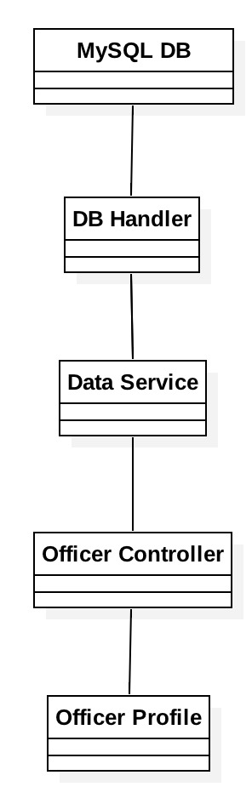

**Unit Test**

* Test case ID: 1
* Description/Summary of Test: User can mark and unmark locations that have been visited. They also have the ability to unmark them all at once.
* Pre-condition: User is logged in. User have watch orders in the the View Watch Order Screen.
* Expected Results: User was able to mark and unmark the visited locations and the user was also able to unmark them all.
* Actual Result: User was able to mark and unmark the visited locations and the user was also able to unmark them all.
* Status (Fail/Pass): Pass

**Integration Test**

**Visual User Guide** <like one or two screenshots of the feature. For the hardware project, a photo of device is required>